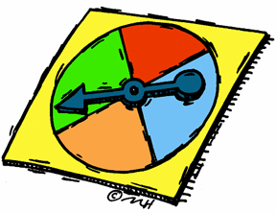
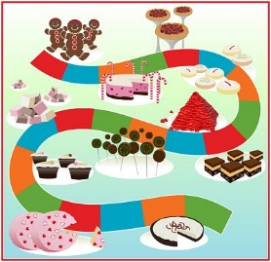
Design a Board Game
Book Report
DUE: September 30, 2016

You will be creating a board game for your project on the book of choice summer reading assignment.
- Create a playing board designed with a path of spaces leading from “Start” to “Finish.” In each space you will mention events that happened in your book. Include the main idea, some of the important details and action events from the book in your spaces. Your spaces may instruct the player how to move their playing pieces or you may make cards to tell them how to move. For example, a space or a card may say, “Nancy finds a clue in the clock. Move ahead two spaces.” Also, include some “foils” such as, “Nancy runs out of gas, miss your next turn.” BE CREATIVE!!! (If you need some ideas, please come see me!)
- Your playing board should show the setting of your book.
- The name of your game should be the title of your book.
- Be sure to write the name of the author on the board.
- Construct playing pieces to represent the characters in your book.
- Decide how your playing pieces will move through your game and collect the appropriate materials such as dice or spinners etc.
- Write clear directions explaining the rules of your game.
- Put the pieces together in a box or zip type plastic bag so you won’t lose any pieces.
- Be sure your name is on your project and bring it to school on September 30, 2016.
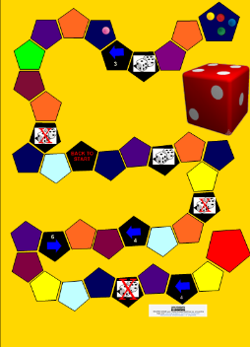
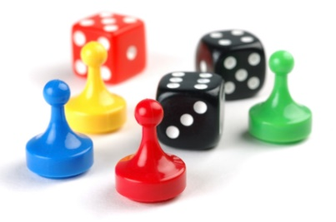
Design a Board Game - Book Report Rubric
Teacher: |  |  | Student Name:
CATEGORY | 10 | 8 |  | 6 | 4
Written Planning and Preparation for Game | Student thoughtfully and completely answered all the planning questions provided using complete sentences. | Student thoughtfully and completely answered most of the planning questions provided using complete sentences. |  | Student thoughtfully and completely answered some of the planning questions, but did not use complete sentences. | Student did not answer the planning questions provided.
Story Elements/ Questions | Game provides participants with specific information about the setting, characters, and problems or events of the story. (a minimum of 15 questions or information cards) | Game provides participants with some specific information about the setting, characters, and problems or events of the story. (10-14 questions or information cards) |  | Game provides participants with minimum specific information about the setting, characters, and problems or events of the story. (5-9 questions or information cards) | Game does not provide participants with specific information about the setting, characters, and problems or events of the story.
Rules and Directions | Student put obvious thought and effort into the rules and directions, making the game easily understood and playable. | Student put thought and effort into the rules and directions, making the game somewhat understandable. |  | Student put little thought and effort into the rules and directions, making the game confusing and hard to play. | The rules and directions were not provided.
Does it work? | Game makes logical sense, is easy to follow, and proceeds as directed by rules and descriptions provided. | Game makes sense and proceeds as directed by rules and descriptions provided. |  | Game is confusing, making it difficult to play. | Game does not make sense making it impossible to play.
Design and Creativity | Time and effort were obviously put into creating the game. Everything is neatly created and directions were followed completely. | Some effort was obviously put into creating the game. Game board is excellent but some parts are a little sloppy. |  | Game board is complete, but elements are missing, some of the directions were ignored and the board is sloppy. | There is a game board but it is not colored and no extra efforts were made at creativity.
Spelling | Game, directions, cards, and play pieces are free from spelling errors. | Game, directions, cards, and play pieces have 1-3 spelling errors. |  | Game, directions, cards, and play pieces have 4-6 spelling errors. | Game, directions, cards, and play pieces have more than 6 spelling errors.
Mechanics/ Grammar | Game, directions, cards, and play pieces are free from grammatical, capitalization, and punctuation errors. | Game, directions, cards, and play pieces contain 1-3 grammatical, capitalization, and punctuation errors. |  | Game, directions, cards, and play pieces contain 4-6 grammatical, capitalization, and punctuation errors. | Game, directions, cards, and play pieces contain more than 6 grammatical, capitalization, and punctuation errors.

Total Points: ____/70
Student Name: _________________________________________________
Fill out this worksheet to help you design your board game.
*Turn in with your board game.*

Book Title: __________________________________________________
Author: ____________________________________________________

1. Write the characters’ names, along with a sentence identifying each one.
a.___________________________________________________________________________________________________________________________________
b.___________________________________________________________________________________________________________________________________
c.___________________________________________________________________________________________________________________________________
d.___________________________________________________________________________________________________________________________________
e.___________________________________________________________________________________________________________________________________
2. Using complete sentences, describe the setting of the story.
______________________________________________________________________________________________________________________________________________________________________________________________________
3. Using complete sentences, briefly describe the main conflict or problem. Explain how the conflict was resolved.
________________________________________________________________________________________________________________________________________________________________________________________________________________________________________________________________________
5. Think about how you can design a board game based on all or some of the information above (characters, setting, conflict, and resolution). Keep in mind that players should be able to play the game even if they have not read the book.
a. How is the game played? What are the rules?
______________________________________________________________________________________________________________________________________________________________________________________________________
b. What will the game board and playing pieces look like?
______________________________________________________________________________________________________________________________________________________________________________________________________
c. How does someone win the game? (Will they reach FINISH first? Will they collect the most points along the way?)
______________________________________________________________________________________________________________________________________________________________________________________________________
d. Will you use a spinner, cards, or dice in your game?
______________________________________________________________________________________________________________________________________________________________________________________________________
6. On a separate piece of paper, sketch the game board. Test your game to make sure it works.
7. On a separate piece of paper, write/type clear directions explaining how to play the game. (The simpler you keep the game; the easier it is to play.) Number each step in the directions.
8. Make a final copy of your game board and any other parts (cards, spinner, playing pieces, and so on). Design the board so that it is colorful, neat, and attractive.

